Crime Prevention Unit

CPTED SECURITY SURVEY
OF
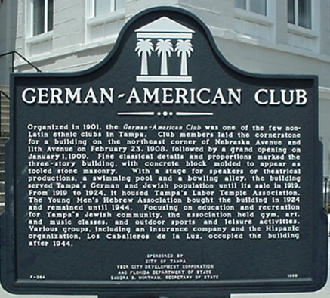

German - American Club

xxxx N. Nebraska Ave.

SURVEY CONDUCTED BY

Officer , FCPP, CPTED
Officer , FCPP, CPTED

August 23, 2004

DISCLAIMER

This security survey has been conducted as a public service of the Tampa Police Department’s Crime Prevention Through Environmental Design (CPTED) Unit. The information contained herein is based on guidelines set by the Florida Crime Prevention Training Institute and the observations of the individual officer conducting the survey. This survey is intended to assist you in improving the overall level of security only. It is not intended to imply the existing security measures, or proposed security measures are absolute or perfect.

CONTACT: Jake Slater
Manager
Business Tax Division
XXXX N. Nebraska Ave.
Ground Floor
Tampa, FL 33602
P. O. Box XXXX
Tampa, FL 33601-2200
(813) XXXXXXX

SITE LOCATION: City of Tampa Offices
German American Club Building
XXXX N. Nebraska Ave.
Tampa, FL 33602

DATE: August 23, 2004

CONFIDENTIALITY OF REPORT

281.301 Security systems; records and meetings exempt from public access or disclosure.—Information relating to the security systems for any property owned by or leased to the state or any of its political subdivisions, and information relating to the security systems for any privately owned or leased property which is in the possession of any agency as defined in s. 119.011(2), including all records, information, photographs, audio and visual presentations, schematic diagrams, surveys, recommendations, or consultations or portions thereof relating directly to or revealing such systems or information, and all meetings relating directly to or that would reveal such systems or information are confidential and exempt from ss. 119.07(1) and 286.011 and other laws and rules requiring public access or disclosure.
History.—s. 1, ch. 87-355; s. 1, ch. 89-47; s. 101, ch. 90-360; s. 130, ch. 96-406.

The Tampa Police Department was requested to conduct a security survey of the German American Club Building, located at 2105 N. Nebraska Ave. Tampa, Florida 33602, by Mr. Jake Slater, Manager, Business Tax Division. This report is based on available intelligence, analysis of crime statistics, on-site inspections, and interviews conducted at the site for the exterior of the building and common areas only. The recommendations are based on concepts and strategies of Crime Prevention Through Environmental Design (CPTED) and traditional crime prevention organizational and mechanical methods of target hardening. The CPTED concept is that the proper design and effective use of the built environment can lead to the reduction of crime and improvement in the quality of life. CPTED reviews involve four overlapping strategies. The strategies are Natural Surveillance, Territorial Reinforcement, Natural Access Control, and Target Hardening.

- NATURAL SURVEILLANCE – Is a design concept intended to allow intruders and offenders to be easily viewable to people passing the property and those using the property.
- TERRITORIAL REINFORCEMENT – Is a strategy to create and/or extend the property’s sphere of influence, which is the perception that someone is in control of the area. This strategy distinguishes what is private space from public space by using landscaping, pavement designs, signage and fences.
- NATURAL ACCESS CONTROL – This strategy is intended to decrease the opportunity for offending by denying access to a crime target and increasing the perception of risk to the offender.
- TARGET HARDENING – This strategy enhances the physical security of crime target through the use of locks, door and window types, security alarms, and other crime prevention methods.

SITE ANALYSIS

The analysis of reported crime is an important element in conducting a security survey. By conducting an analysis, the type of crime that is occurring can be determined and possible trends identified. It is important to understand crime trends in the area to determine security needs and potential risks. The German American Club Building is located in Tampa Police grid #127. The boundaries for grid #127 are:

Grid #127
North: I-4
South: E. Adamo
East: N. 15th St.
West: N. Nebraska Ave.

In evaluating criminal activity within grid #127, the Federal Bureau of Investigation’s Uniform Crime Report (UCR) records generated by the Tampa Police Department are used. The UCR is divided into two categories: Part I or index crimes and, Part II or quality of life crimes. Part I crimes consist of Murder, Rape, Robbery, Aggravated Assault, Burglary, Theft, and Automobile Theft. Murder, Rape, Robbery and Aggravated Assault are studied to identify violent crime trends, while Burglary, Theft and Automobile Theft are used to evaluate property crime trends. Part II crimes consist of such crimes as Vandalism, Trespassing, Narcotic Violations, etc., which is used as an indication of levels of street crimes and fear of crime. The definitions for the crime categories are universal throughout the United States and provided by the FBI. These crime categories are used to gauge fluctuations in the volume and rate of crime; the Tampa Police Department rates certain crimes in relation to each grid to identify if the rate of occurrence. The definitions for evaluation are listed below:

RATING | DESCRIPTION
HIGH | Double & above the number of crimes in Tampa (>200% +)
ABOVE | One & one-half to almost double the number of crimes in Tampa (150% to 199.99%)
AVERAGE | Three quarters to almost one & one-half the number of crimes in Tampa (75% to 149.99%)
BELOW | One half to almost three quarters the number of crimes in Tampa (50% to 74.99%)
LOW | Less than half the number of crimes in Tampa (<less than 50%)

In evaluating the Part I and Part II crimes that occur most frequently, the Tampa Police Department evaluated the following crimes categories for the years 2001- 2003 for grid #127:

Grid #127 city-wide comparison for 2001-2003
PART I CRIMES
Category | Occurrence |  |  | Rating | City Average
Sexual Assault | 5 |  |  | Average | 4.40
Robbery | 67 |  |  | High | 30.30
Aggravated Assault |  | 101 |  | High | 44.52
Burglary |  | 120 |  | Average | 88.16
Larceny / Building |  | 76 |  | Above | 38.31
Burglary of Vehicle |  | 440 |  | High | 144.47
Vehicle Theft |  | 186 |  | Above | 93.24

PART II CRIMES
Vandalism |  |  | 133 | High | 49.38
Prostitution |  |  | 4 | Low | 10.12
Liquor Law Violations |  |  | 131 | High | 18.05
Simple Assault |  |  | 191 | High | 83.10
Drugs |  |  | 119 | Above | 64.25

GRID 127
 | Murder | Sexual Battery | Robbery |  | Aggravated Assault |  | Burglary | Theft | Auto Burglary | Motor Vehicle Theft
1999 | 0 | 2 |  | 31 |  | 42 | 24 | 102 | 128 | 79
2000 | 1 | 2 |  | 36 |  | 43 | 43 | 84 | 101 | 65
2001 | 1 | 2 |  | 21 |  | 42 | 44 | 75 | 186 | 90
2002 | 0 | 2 |  | 25 |  | 27 | 41 | 66 | 147 | 57
2003 | 0 | 1 |  | 20 |  | 32 | 34 | 32 | 107 | 40
Total | 2 | 9 |  | 133 |  | 186 | 206 | 359 | 669 | 331

GRID 127
 | UCR PART 1  CRIMES | UCR PART 2  CRIMES | TOTAL REPORTED CRIME
1999 | 408 | 325 | 733
2000 | 375 | 286 | 661
2001 | 461 | 304 | 765
2002 | 365 | 291 | 657
2003 | 266 | 167 | 433
total | 1875 | 1373 | 3249

German American Club
Calls for Service
January 1, 2004 to  August 20, 2004 |  | 2105 N. Nebraska Ave.
Type of Event |  | Number of Calls
Trespass |  | 2
Burglary |  | 3
Petit Theft |  | 1
Burglary of Vehicles |  | 3
Found Property |  | 1
Supplement Report |  | 3
Abandoned Vehicle |  | 1
Assist Motorist |  | 1
Misdemeanor |  | 1
Suspicious Persons |  | 1
Alarm |  | 1
Crime Prevention Activity |  | 1
Battery |  | 1
Total Number of Events |  | 20

No significant crime trends were discovered in grid (#127) however, compared to the other grids throughout the city, crime appears to be high or above average.

A five-year look at grid (#127) alone shows auto burglary to be the main Part I crime followed by theft and then vehicle theft.

A recent look at the calls for police service from January to the present of building property shows auto burglary along with burglary, theft, and trespass occurring more than one time.

- Site Assessment and Recommendations:

The information contained in this review is based on guidelines set by the Florida Crime Prevention Training Institute, as well as my own observations. It is intended to assist you in improving the overall level of security of your business and should be construed as suggestions only.

Due to the specific request the emphasis of this report is on the parking areas, building exteriors and common areas. Individual departments and their security procedures are not reviewed in this report.

To determine the security needs of this building, there are several factors that should be considered, one of which is “risk potential”. The second is “probable maximum loss” versus “possible maximum loss” to a criminal act. A systematic approach must be initiated to decide on the highest level of protection available at the lowest cost to the establishment.

- South Parking Lot

Patrons and employees use the south parking lot. The lot is randomly patrolled by security throughout the day. At this time the lot is not protected by physical barriers and is vulnerable to criminal activity. Fencing is recommended to surround the east, west, and south parameters of the parking lot. CPTED type fencing which is fencing that allows for natural surveillance should be used. Wrought iron or decorative type fencing eliminates hiding areas that could turn into ambush points and allows for natural surveillance of the area.
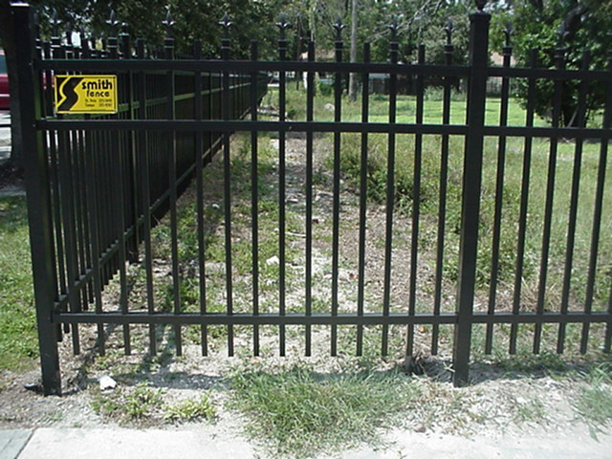

CPTED Fencing.

Existing fencing is along part of the east perimeter of the lot, but has little deterrence. Presently an intruder has uninterrupted access to the parking lot from this area.

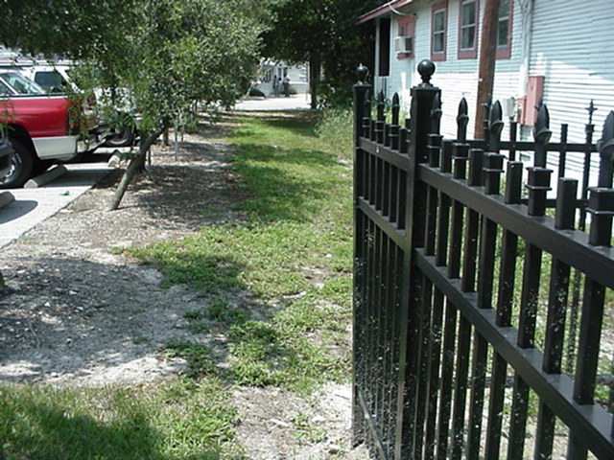
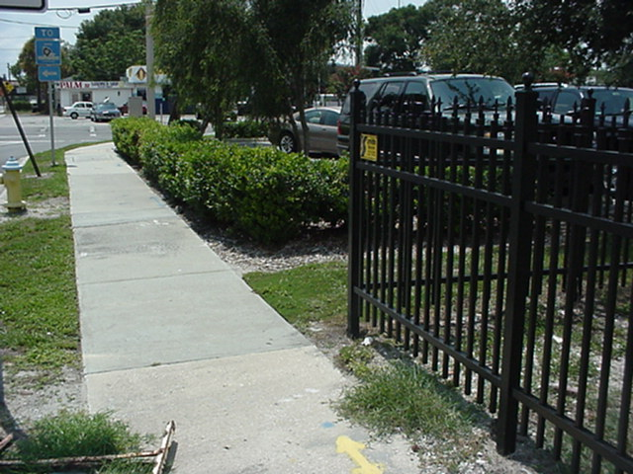

South perimeter - Open access.
East perimeter – Open access.

The existing hedges that run along the south and west perimeter of the lot should be removed and replaced with CPTED type fencing. If the hedges are not removed they should be trimmed down to two feet. Existing trees around the lot should be trimmed upward to six feet. One of the most common applications of landscaping relative to natural surveillance is the two foot six foot rule. This number represents the ideal height of shrubbery and the lowest limbs on trees to allow for a maximum visibility of the area. All landscaping should follow this rule.

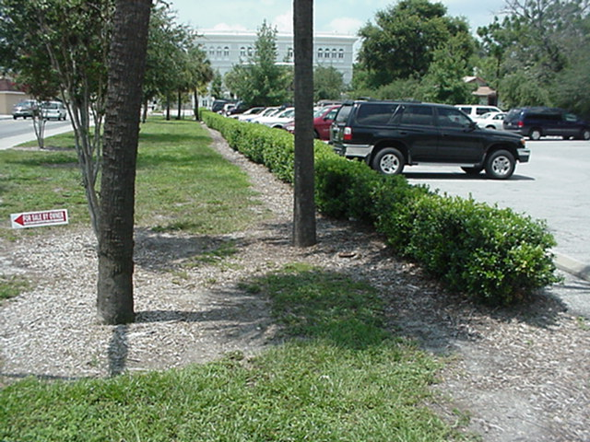
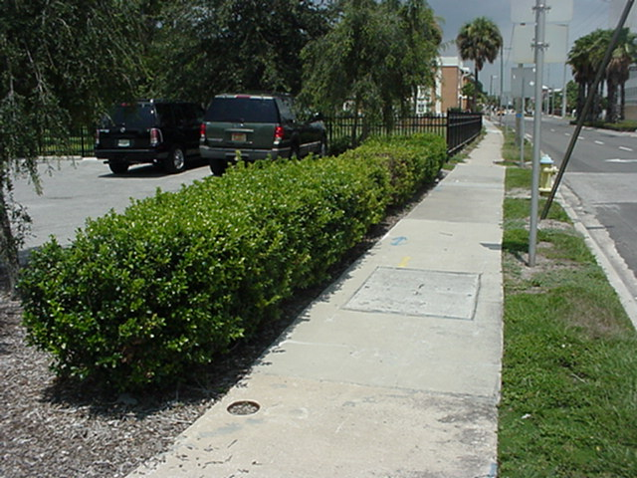

West perimeter looking north.
West perimeter looking south.

Proper lighting is a good psychological barrier and is a major deterrent to nighttime crime. Lighting and landscaping go hand in hand. Poor landscape planning can hinder your lighting several years in the future. This could result in high cost to fix the problem and the potential for inviting criminal activity.

At this time the site is not open during evening hours. If employees use the site and parking lot during night hours the lighting should consists of metal halide lighting. If there is no use after hours then high-pressure sodium should suffice. Limit light trespass and glare. The Illuminating Engineering Society (IES) recommends that “for people to have a reasonable perception of security in parking lots the horizontal illumination on the pavement should be somewhere between 1 and 5 footcandles.” The IES also recommends that the vertical illuminance uniformity be within a ratio of 4:1, average to minimum. These guidelines allow for early detection of suspicious or threatening behavior.

 | Recommended Illumination
Type of Space | Horizontal | Vertical
Public Space | 1-5 fc | .5-.8 fc 5’ above ground
Open Parking | minimum 3 fc on pavement | .3 fc at 5’ above ground
Sidewalks and grounds | minimum .6 fc at ground level | .6 fc at 5’ above ground
 | Source: IES Lighting Handbook, 2000

- Parking Vehicles / South Lot

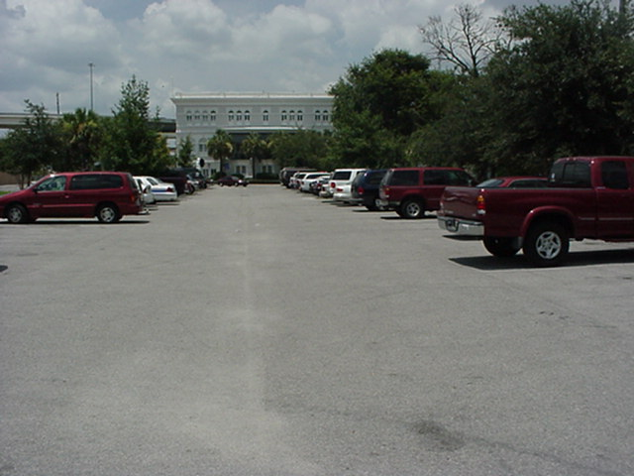
Employees are encouraged to park in the south area of the parking lot to leave room for patrons to park closer to the building. This arrangement leaves the south area of the lot secluded and vulnerable to criminal activity.
Employee Parking
Patron Parking
Patron Parking
The front parking spaces closest to the building should be reserved for employee parking and the far south parking spaces should be used for patrons. By making this arrangement consistent pedestrian traffic is forced to the outer part of the lot eliminating it from being secluded. This will create a safe act, (pedestrian traffic), in an unsafe area, (the secluded part of the lot).

Natural surveillance from the building looking out into the parking lot should be encouraged. Presently the second floor balcony which is used for employee breaks is secluded with overgrown landscaping. This area should be pruned to allow employees to look out into the parking lot. This will allow potential intruders to feel watched and allow employees on break to see suspicious activity.

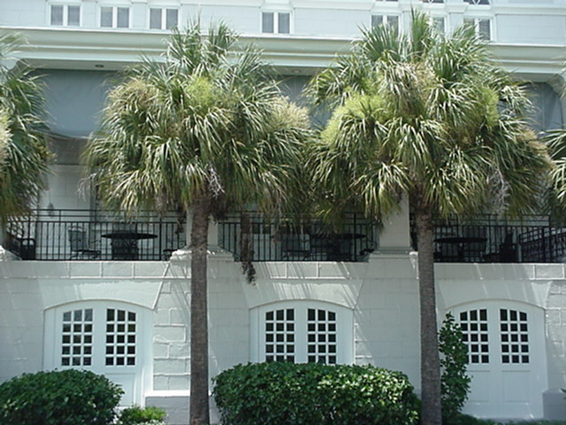
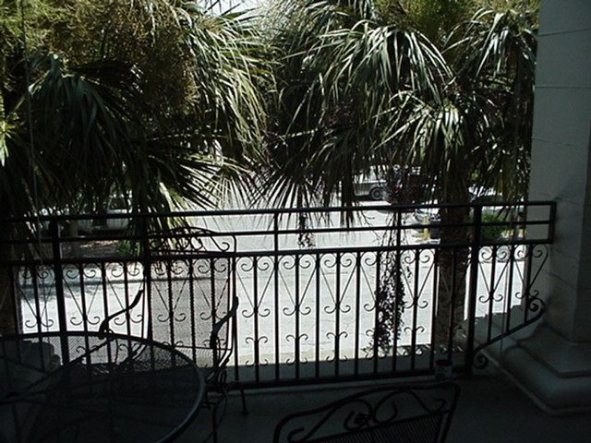

View from south parking lot.
View from balcony looking into lot.

- Pedestrian Safety / South Lot

The south parking has a continuous flow of pedestrian traffic throughout the day. Pedestrians have to cross N. 12th Street to reach the building. The crossing area is very busy with vehicle traffic entering and exiting the parking lot and turning off of N. Nebraska Ave. Traffic calming techniques should be incorporated into the area. Raised pedestrian crosswalks, speed humps, etc. are forms of traffic calming. A pedestrian crosswalk should be considered to direct foot traffic with architectural elements, such as special paving, to calm traffic. This crosswalk should be located just east of the entrance to the lot.
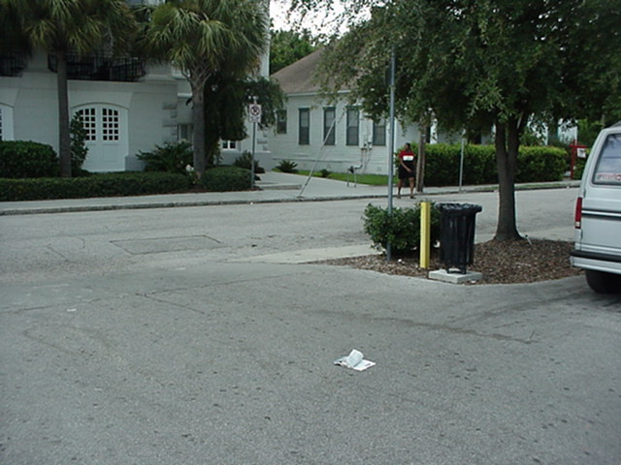
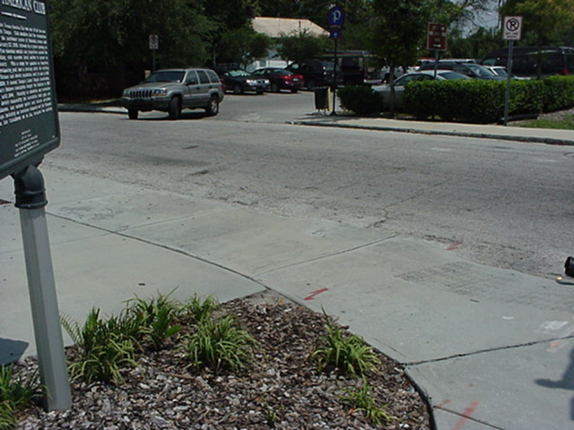

Pedestrians currently cross.
Recommended crosswalk.

Once across the street pedestrians should be directed with signs or artwork to their destination.

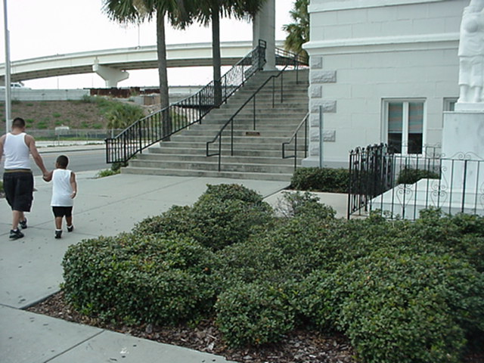
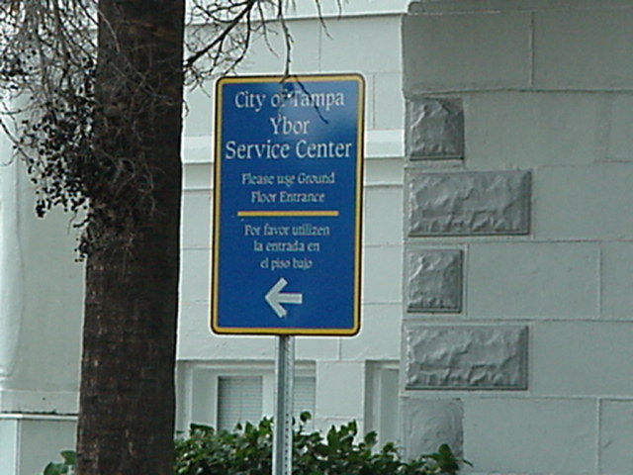

Signage or artwork needed in this area to direct pedestrians.
Unnoticed sign in current location.
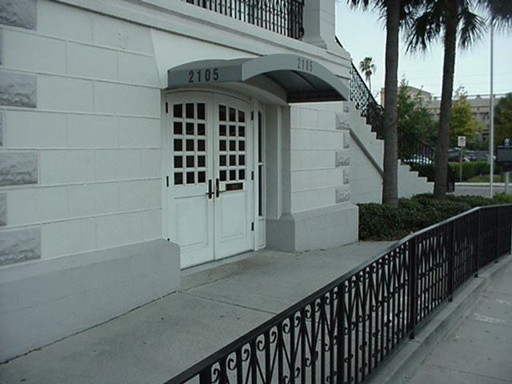

Signage needed on wall identifying services.

- North Parking Lot

The north parking lot is limited to handicap parking and is used as a drive through for a utility bill drop box. This area should have CPTED fencing around the north and east perimeter of the lot. A study should be done to determine how often the utility bill drop box is used. If no more that 25% of utility customers use the box it should be discontinued. If the box is continued to be used it should be identified better for patrons with an awning and signage and the box should be better secured. Traffic calming techniques should be used throughout the lot for the safety of handicap pedestrians and a crosswalk should be installed.

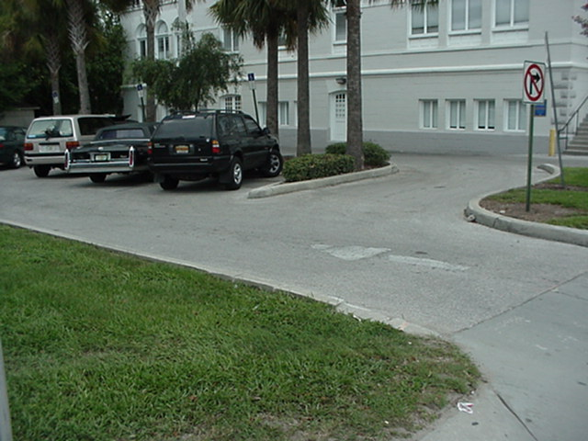

North Parking Lot / Handicap / Drive Through

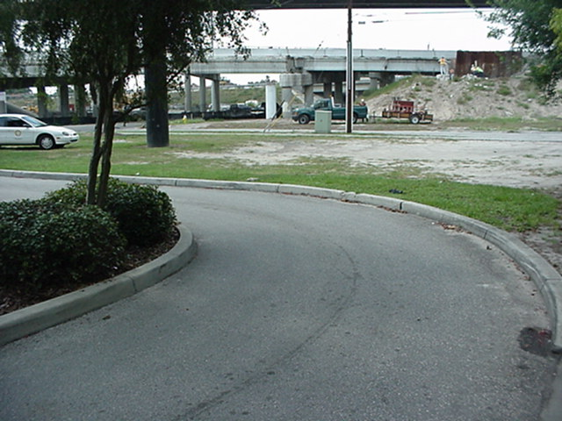

North perimeter of lot.

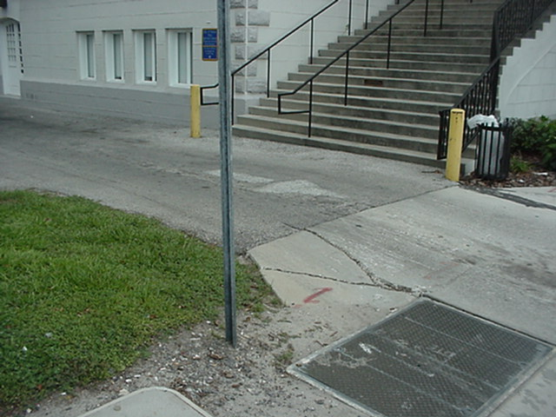

A pedestrian crosswalk is needed in this area for handicap pedestrians. Vehicle traffic from the drop box exits this area.

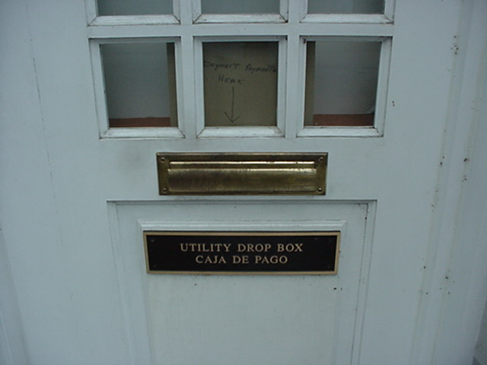

This drop box should be identified better and more secured. Consideration should be given to discontinue use.

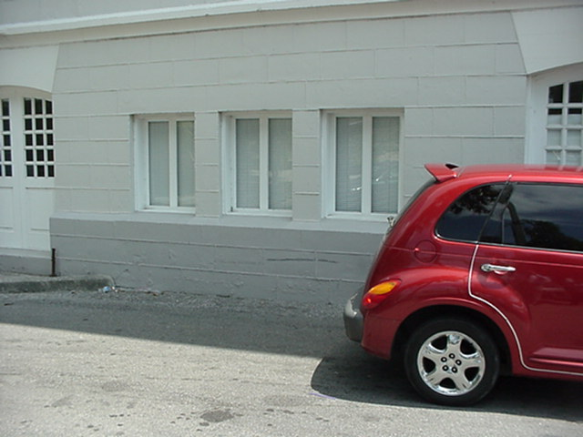

Window blinds should be open to allow for natural surveillance into the parking lot.

The walls partially surrounding the electrical box in the north parking lot is a safety hazard creating a safe haven for vagrants to sleep and loiter. It also creates an ambush point for criminals. The walls should be removed.

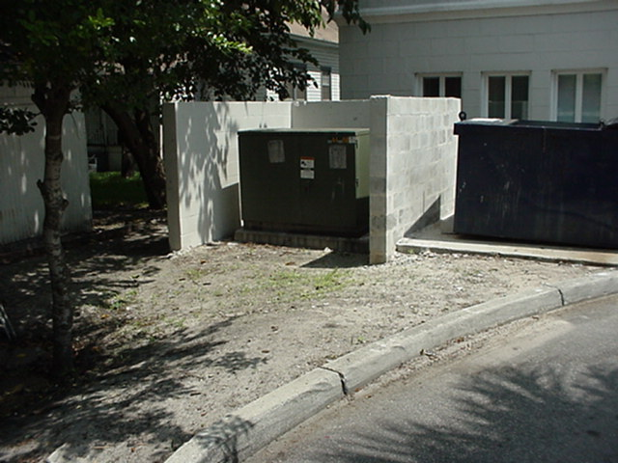

Remove walls.

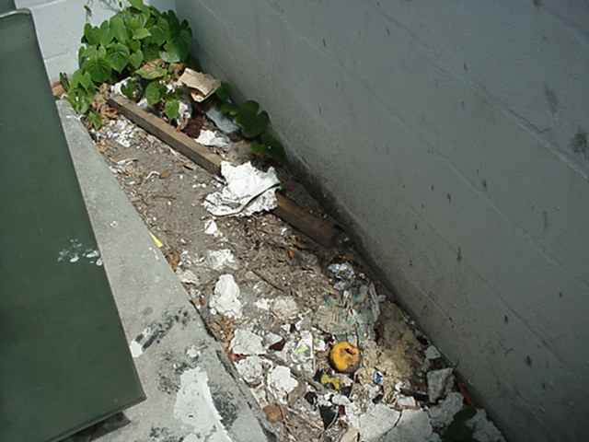

Behind the electrical box. Evidence of vagrants loitering. Feces and strong urine smell along with trash.

- Outside Break Area / South Rear Side Of Building

This area is a good natural surveillance area for the south parking lot and the side of the building. The landscaping in this area should be well pruned to eliminate ambush points and allow for good natural surveillance of the area. The door leading to this area should be closed and locked at all times. The lock on the door is a combination lock. The combination should be changed every time an employee no longer works at this site. New locking hardware should be considered for this door. This door is vulnerable due to the combination having to be changed often and the glass on the door. The glass is easy to break allowing an intruder to reach through and push open the door from the inside. The doors leading into the stairwell from the inside of the building should be locked at all times.

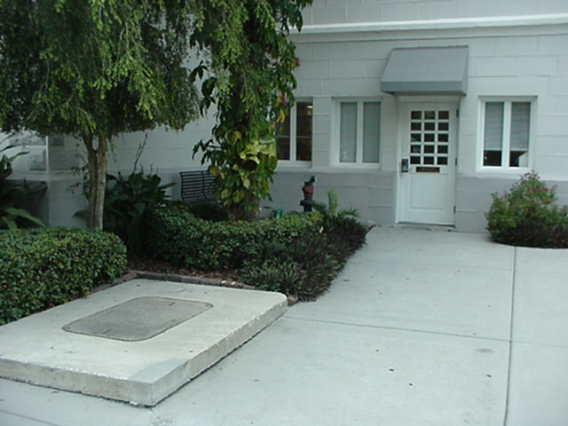

Back break area. Landscaping should be well pruned for natural surveillance.

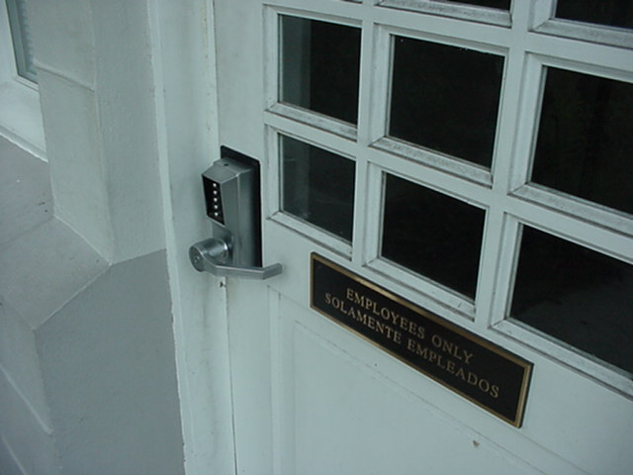
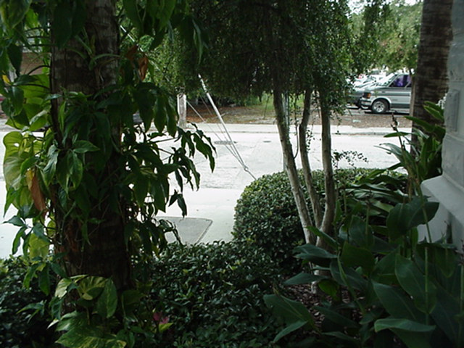

Looking out from break area.
Door vulnerable due to glass and lock.

- Inside Reception Area

This area has a security guard and a restroom. The security guard is usually in this area, but will routinely roam in the parking lots. Due to patrons sometimes being upset and potentially violent, due to unpaid bills, the primary purpose of the security guard is to deter violence from occurring to employees. This is accomplished by the security guard’s presence and the guard alerting police at the first sign of trouble. The security guard should stay in this area at all times and greet every patron that walks in. This creates an uneasy feeling for someone without a legitimate reason for being there.

The restroom is open and secluded. This area creates a staging area for a robbery or other criminal acts. The restroom should be locked at all times and accessible with a key. The security guard should have control and be responsible for the key to the restroom.

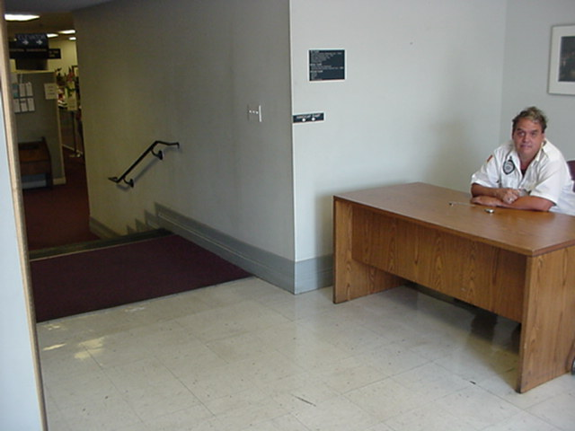
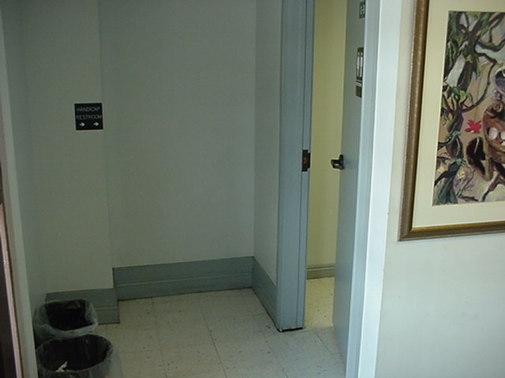

Security should greet patrons.
Restroom locked at all times.

- Inside Lobby

The inside lobby has chairs for patrons to sit and a drop box for utility bills. This areas natural surveillance is limited for employees. This creates another staging area for a robbery or other criminal activity. Windows should be placed along the solid wall allowing the cashiers to see the area. The drop box should be secured to the wall or ground to prevent someone from attempting to pick it up and walk out.

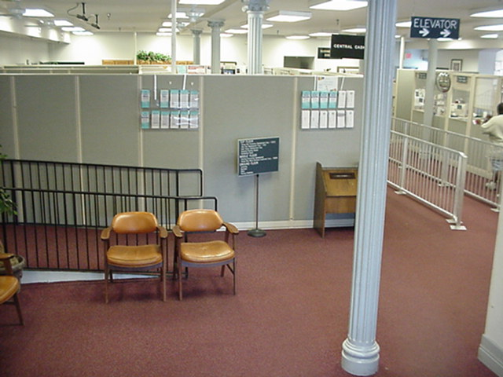

Place windows in this area to create natural surveillance and eliminate a staging area for a robbery or other criminal activity.

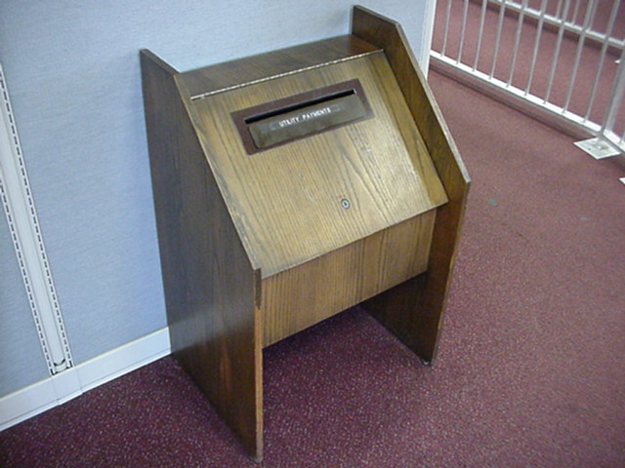
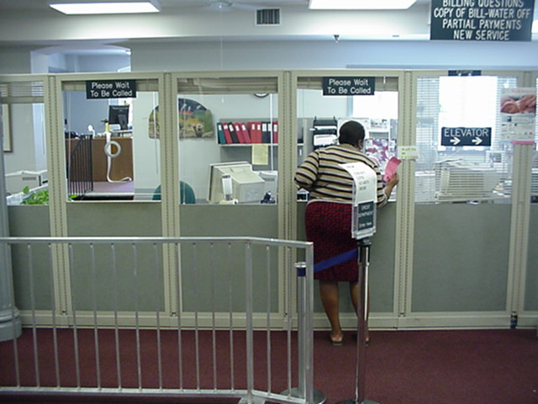

This area looks partially into the lobby, but no one is looking.
Secure to the floor or wall.

- Service Area

The service area accommodates different departmental needs for patrons. The cashier area should be secured at all times and all accesses leading to other departmental areas should be secured as well. If employees from other departments need to make money deposits with the cashier a separate area that is controlled and away from the general public should be created. No one except authorized personnel should be allowed in the cashier area.

The phone area is secluded and allows a staging area for a robbery or other criminal acts. Windows should be placed along the wall allowing employees to see into this area or the phones should be moved to the lobby and the offices extended out to cover the secluded area.

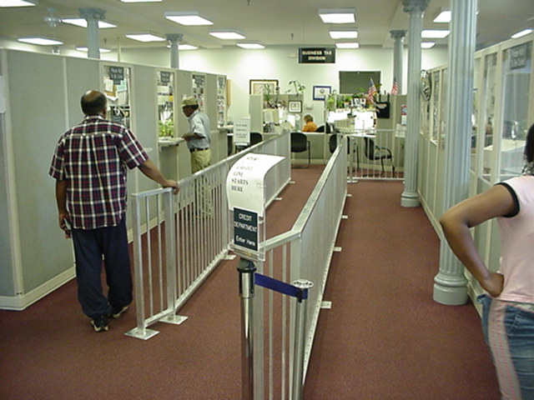

Service area.

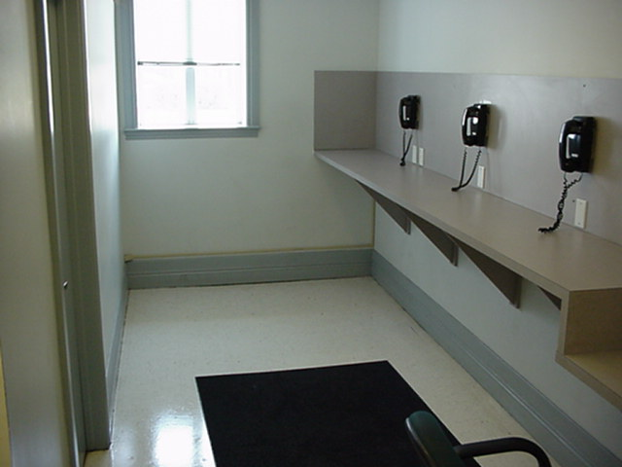
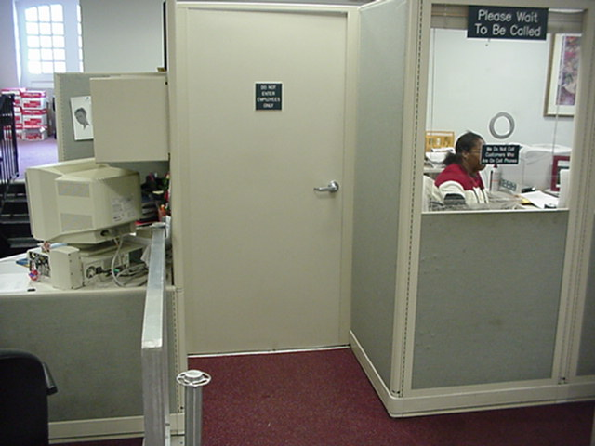

Door locked at all times.
Windows / or move phones.

- Employee Training

The Tampa Police Department has created a series of programs to help assist your employees with crime prevention techniques. Each program is conducted on site and lasts about an hour. All programs are a public service of the Tampa Police Department.

Workplace Violence – One of Corporate America’s top security concerns is workplace violence. Two programs are offered to businesses to meet the company’s needs. The “Management Level Program,” is offered to management and senior supervisors. Topics include pre-employment screening, recognizing patterns of inappropriate behavior, crisis management, legal and liability issues, and physical safety steps for their employees. The “Employee Level Program,” is offered to employees of the business and covers recognizing potentially dangerous behavior, how to address it and how to properly report it. Safety procedures and safeguards are also discussed.

Personal Protection - Criminals often look for opportunities and take advantage of easy targets. The Personal Protection Program gives the audience tips on being aware of their surroundings and recognizing dangerous situations. (Topics include, target hardening, types of criminals, walking, vehicle safety, shopping, weapons, car jacking, and bogus police officers).

Drug Awareness – This program is a straightforward presentation on narcotics and how drug users and communities are affected. Real drug paraphernalia such as pipes and bongs are shown along with police undercover video of drug dealers, drug users and RAVES. (Drugs highlighted are Marijuana, Cocaine, Crack Cocaine, and Designer Drugs).

Road Rage – This program introduces the problems of aggressive driving and road rage. Tips are given to the audience on how to avoid road rage situations stemming from others and even themselves. (10min. Video, “Preventing Road Rage; Anger Management for Drivers,” from the AAA Foundation for Traffic Safety).

Verbal Defense – Physical altercations and other problems are often a result of a miscommunication between two parties. Verbal Judo covers basic communication skills and teaches the audience how to deescalate possible verbal confrontations. (An interactive exercise on communication is demonstrated at the end of the presentation).

Office Security – Criminals often take advantage of the work place environment. The Office Security program gives employees tips on how to keep themselves and their property safe at work. (Topics include personal protection tips, traveling safety, office scams, and work place violence).

- In Conclusion

Due to the amount of patrons that visit the site on a daily basis and the history of the area it is obvious there is a concern for the general welfare and safety of all employees.

By taking a strong stance against crime, you create a comfortable work environment for employees. You are also joining in a partnership with the Tampa Police Department in making the City of Tampa safe.

For additional information on programs please contact the Tampa Police Department Crime Prevention Unit at 813-276-3318.

